ADVANCED DATA STRUCTURE AND ALGORITHM

ASSIGNMENT

SUBMITTED BY:

ALAGU VARSHINI T

22CS014

COMPUTER SCIENCE AND ENGINEERING

1)

def bubble_sort(arr):

n = len(arr)

for i in range(n):

swapped = False

for j in range(0, n-i-1):

if arr[j] > arr[j+1]:

arr[j], arr[j+1] = arr[j+1], arr[j]

swapped = True

if not swapped:

break

arr = [5, 2, 9, 1, 5, 6]

bubble_sort(arr)

print("Sorted array is:", arr)

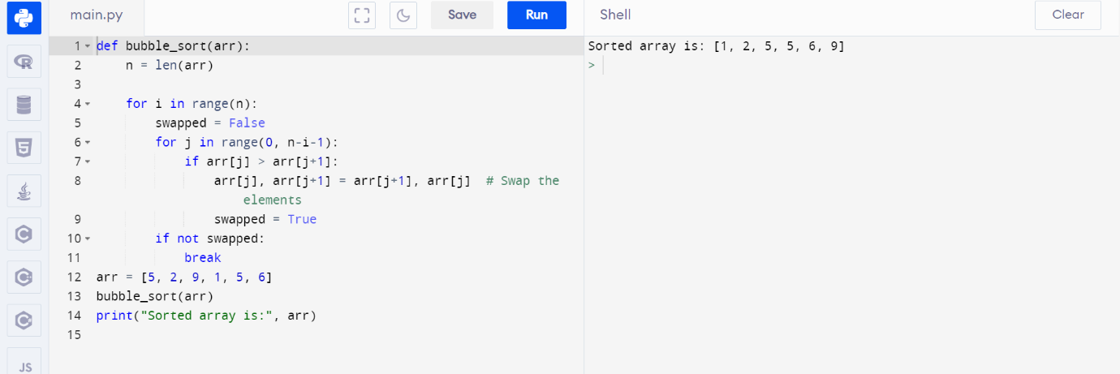

This code will take the unsorted list [5, 2, 9, 1, 5, 6], apply the Bubble Sort algorithm to it, and produce the sorted array [1, 2, 5, 5, 6, 9].

TIME COMPLEXITY:

1.Analyze the time complexity of the sorting algorithm you implemented. Explain whether it is a stable sort and how it performs on different types of input data (e.g., already sorted, reverse sorted, random data).

Time Complexity Analysis:

- Bubble Sort has a time complexity of O(n^2) in the worst and average cases because, in the worst case, it has to perform n * (n-1) / 2 comparisons and swaps.

- In the best-case scenario, when the input array is already sorted, Bubble Sort still requires O(n) comparisons but no swaps, making it more efficient with a best-case time complexity of O(n).

- Bubble Sort is an in-place sorting algorithm, which means it doesn't require additional memory for sorting; it sorts the array in its original place.

Stability:

- Bubble Sort is a stable sorting algorithm. This means that when two elements have equal values, their relative order in the sorted output will be the same as their relative order in the original input.

Performance on Different Input Data:

- Bubble Sort performs well on small datasets or nearly sorted datasets due to its simplicity and low overhead. In these cases, the number of comparisons and swaps is minimal.

- However, Bubble Sort is highly inefficient on large datasets or datasets with a reverse order because it needs to perform a large number of swaps. It doesn't adapt well to the existing order of elements.

5.Compare the time complexity of your chosen sorting algorithm with at least one other sorting algorithm (e.g., Quick Sort, Merge Sort, or Python's built-in **sorted** function). Explain the differences and scenarios where one algorithm might be preferred over the other.

Comparison with Other Sorting Algorithms:

-Quick Sort and Merge Sort are significantly more efficient than Bubble Sort in terms of time complexity. Both Quick Sort and Merge Sort have an average and worst-case time complexity of O(n log n). They are divide-and-conquer algorithms that efficiently handle large datasets and various

2)

def matrix_chain_multiplication(matrices):

n = len(matrices)

m = [[0] * n for _ in range(n)]

s = [[0] * n for _ in range(n)]

for i in range(1, n):

m[i][i] = 0

for l in range(2, n):

for i in range(1, n - l + 1):

j = i + l - 1

m[i][j] = float('inf')

for k in range(i, j):

cost = m[i][k] + m[k + 1][j] + matrices[i - 1][0] * matrices[k][1] * matrices[j][1]

if cost < m[i][j]:

m[i][j] = cost

s[i][j] = k

def print_optimal_parenthesization(i, j):

if i == j:

print(f'Matrix {i}', end='')

else:

print('(', end='')

print_optimal_parenthesization(i, s[i][j])

print_optimal_parenthesization(s[i][j] + 1, j)

print(')', end='')

print("Optimal Parenthesization: ", end='')

print_optimal_parenthesization(1, n - 1)

print()

return m[1][n - 1]

matrices = [(2, 3), (3, 4), (4, 2)]

min_scalar_multiplications = matrix_chain_multiplication(matrices)

print("Minimum Scalar Multiplications:", min_scalar_multiplications)

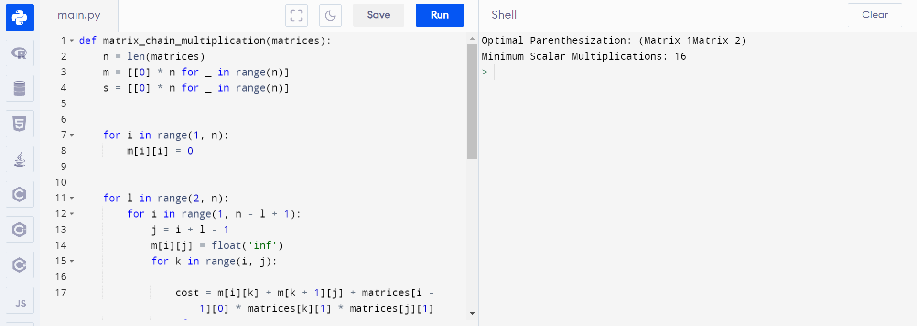

Time and Space Complexity:

Time Complexity: O(n^3), where n is the number of matrices. This is because we have a triple nested loop.

Space Complexity: O(n^2) for the m and s tables.

Efficiency for Large Instances:

The dynamic programming approach is efficient for reasonably sized instances. However, as the number of matrices (n) increases significantly, the time and space complexity can become a limiting factor.

For very large instances, more optimized algorithms such as Strassen's matrix multiplication or parallel computing techniques may be more efficient

3)

def solve_n_queens(n):

def is_safe(board, row, col):

for i in range(row):

if board[i][col] == 'Q':

return False

for i, j in zip(range(row, -1, -1), range(col, -1, -1)):

if board[i][j] == 'Q':

return False

for i, j in zip(range(row, -1, -1), range(col, n)):

if board[i][j] == 'Q':

return False

return True

def backtrack(row):

if row == n:

solutions.append([''.join(row) for row in board])

return

for col in range(n):

if is_safe(board, row, col):

board[row][col] = 'Q'

backtrack(row + 1)

board[row][col] = '.'

solutions = []

board = [['.' for _ in range(n)] for _ in range(n)]

backtrack(0)

return solutions

def print_solutions(solutions):

for solution in solutions:

for row in solution:

print(row)

print()

N = 4

solutions = solve_n_queens(N)

print_solutions(solutions)

Time Complexity Analysis:

The time complexity of this backtracking algorithm is O(N!), where N is the size of the chessboard. In the worst case, it explores all possible permutations of queens.

This algorithm is not efficient for very large values of N due to its factorial time complexity. For N = 8 or 9, it should run reasonably quickly, but for larger N, it becomes impractical.